## **Microsoft Visual Studio Code**

## **Pre-requisites:**

* Microsoft Visual Studio Code setup file ' VSCodeSetup-x64-1.64.1.exe' setup file must be downloaded from below-
* **URL:** https://code.visualstudio.com/docs/?dv=win64
* User should have administrator rights to install the Microsoft Visual Studio Code setup file 'VSCodeSetup-x64-1.64.1.exe

## **Installation:**

* + - Log in to the machine where Microsoft Visual Studio Code will be installed.
    - Navigate to the directory where 'VSCodeSetup-x64-1.64.1.exe' file is copied.
    - Double click on 'VSCodeSetup-x64-1.64.1.exe'. After that the 'License Agreement' windows will be opened Now Click on 'I accept the agreement'.

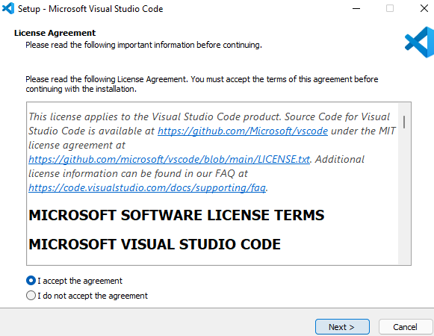

* + - Click on 'Next' Button. After that 'Select Destination Location' windows will be opened.

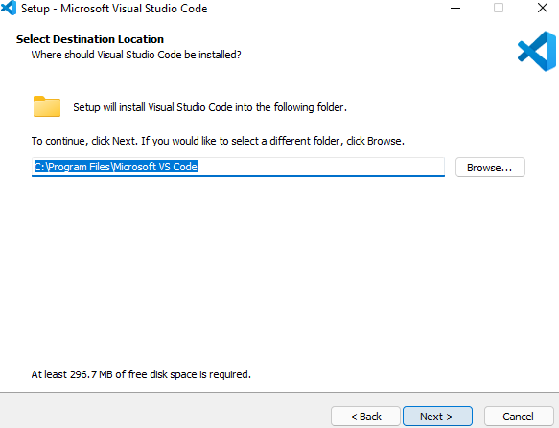

* + - Click on 'Next' Button. After that 'Select Start Menu Folder' windows will be opened.

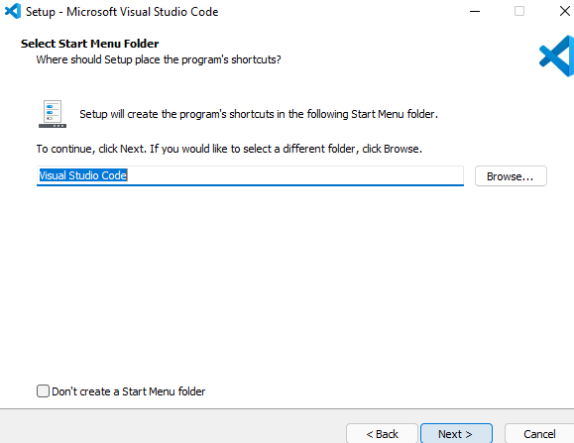

* + - Click on 'Next' Button. After that 'Select Additional Task' windows will be opened.

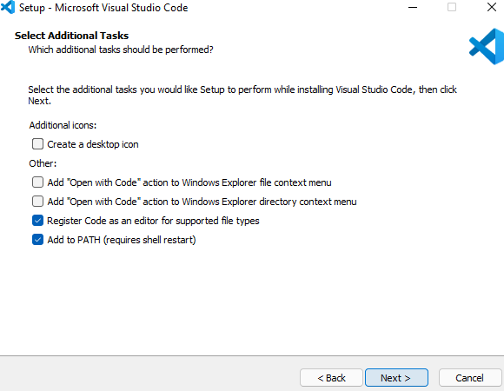

* + - Click on 'Next' Button. After that 'Ready To Install' windows will be opened.

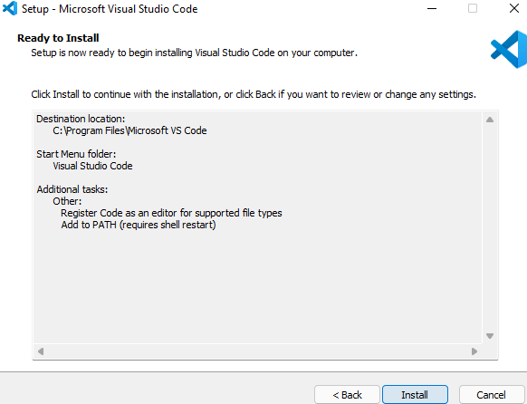

* + - Click on 'Install' Button. After the installation 'Completing the Microsoft Visual Studio Code Setup Wizard' windows will be opened.

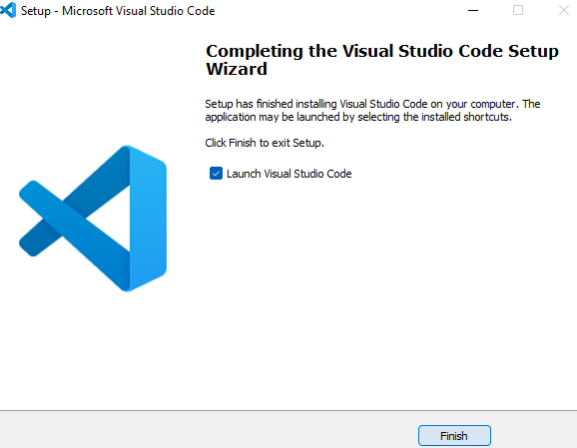

* + - Then Click on 'Finish' Button.

## **Verification:**

* Log in to the machine where Microsoft Visual Studio Code is copied.
* Navigate to the specific directory where 'VSCodeSetup-x64-1.64.1.exe' is copied. (C:\Share\Microsoft_Visual_Studio_Code).
* ' VSCodeSetup-x64-1.64.1.exe' must be present into the directory.

